Norwin High School

Class of 1969
40th Reunion
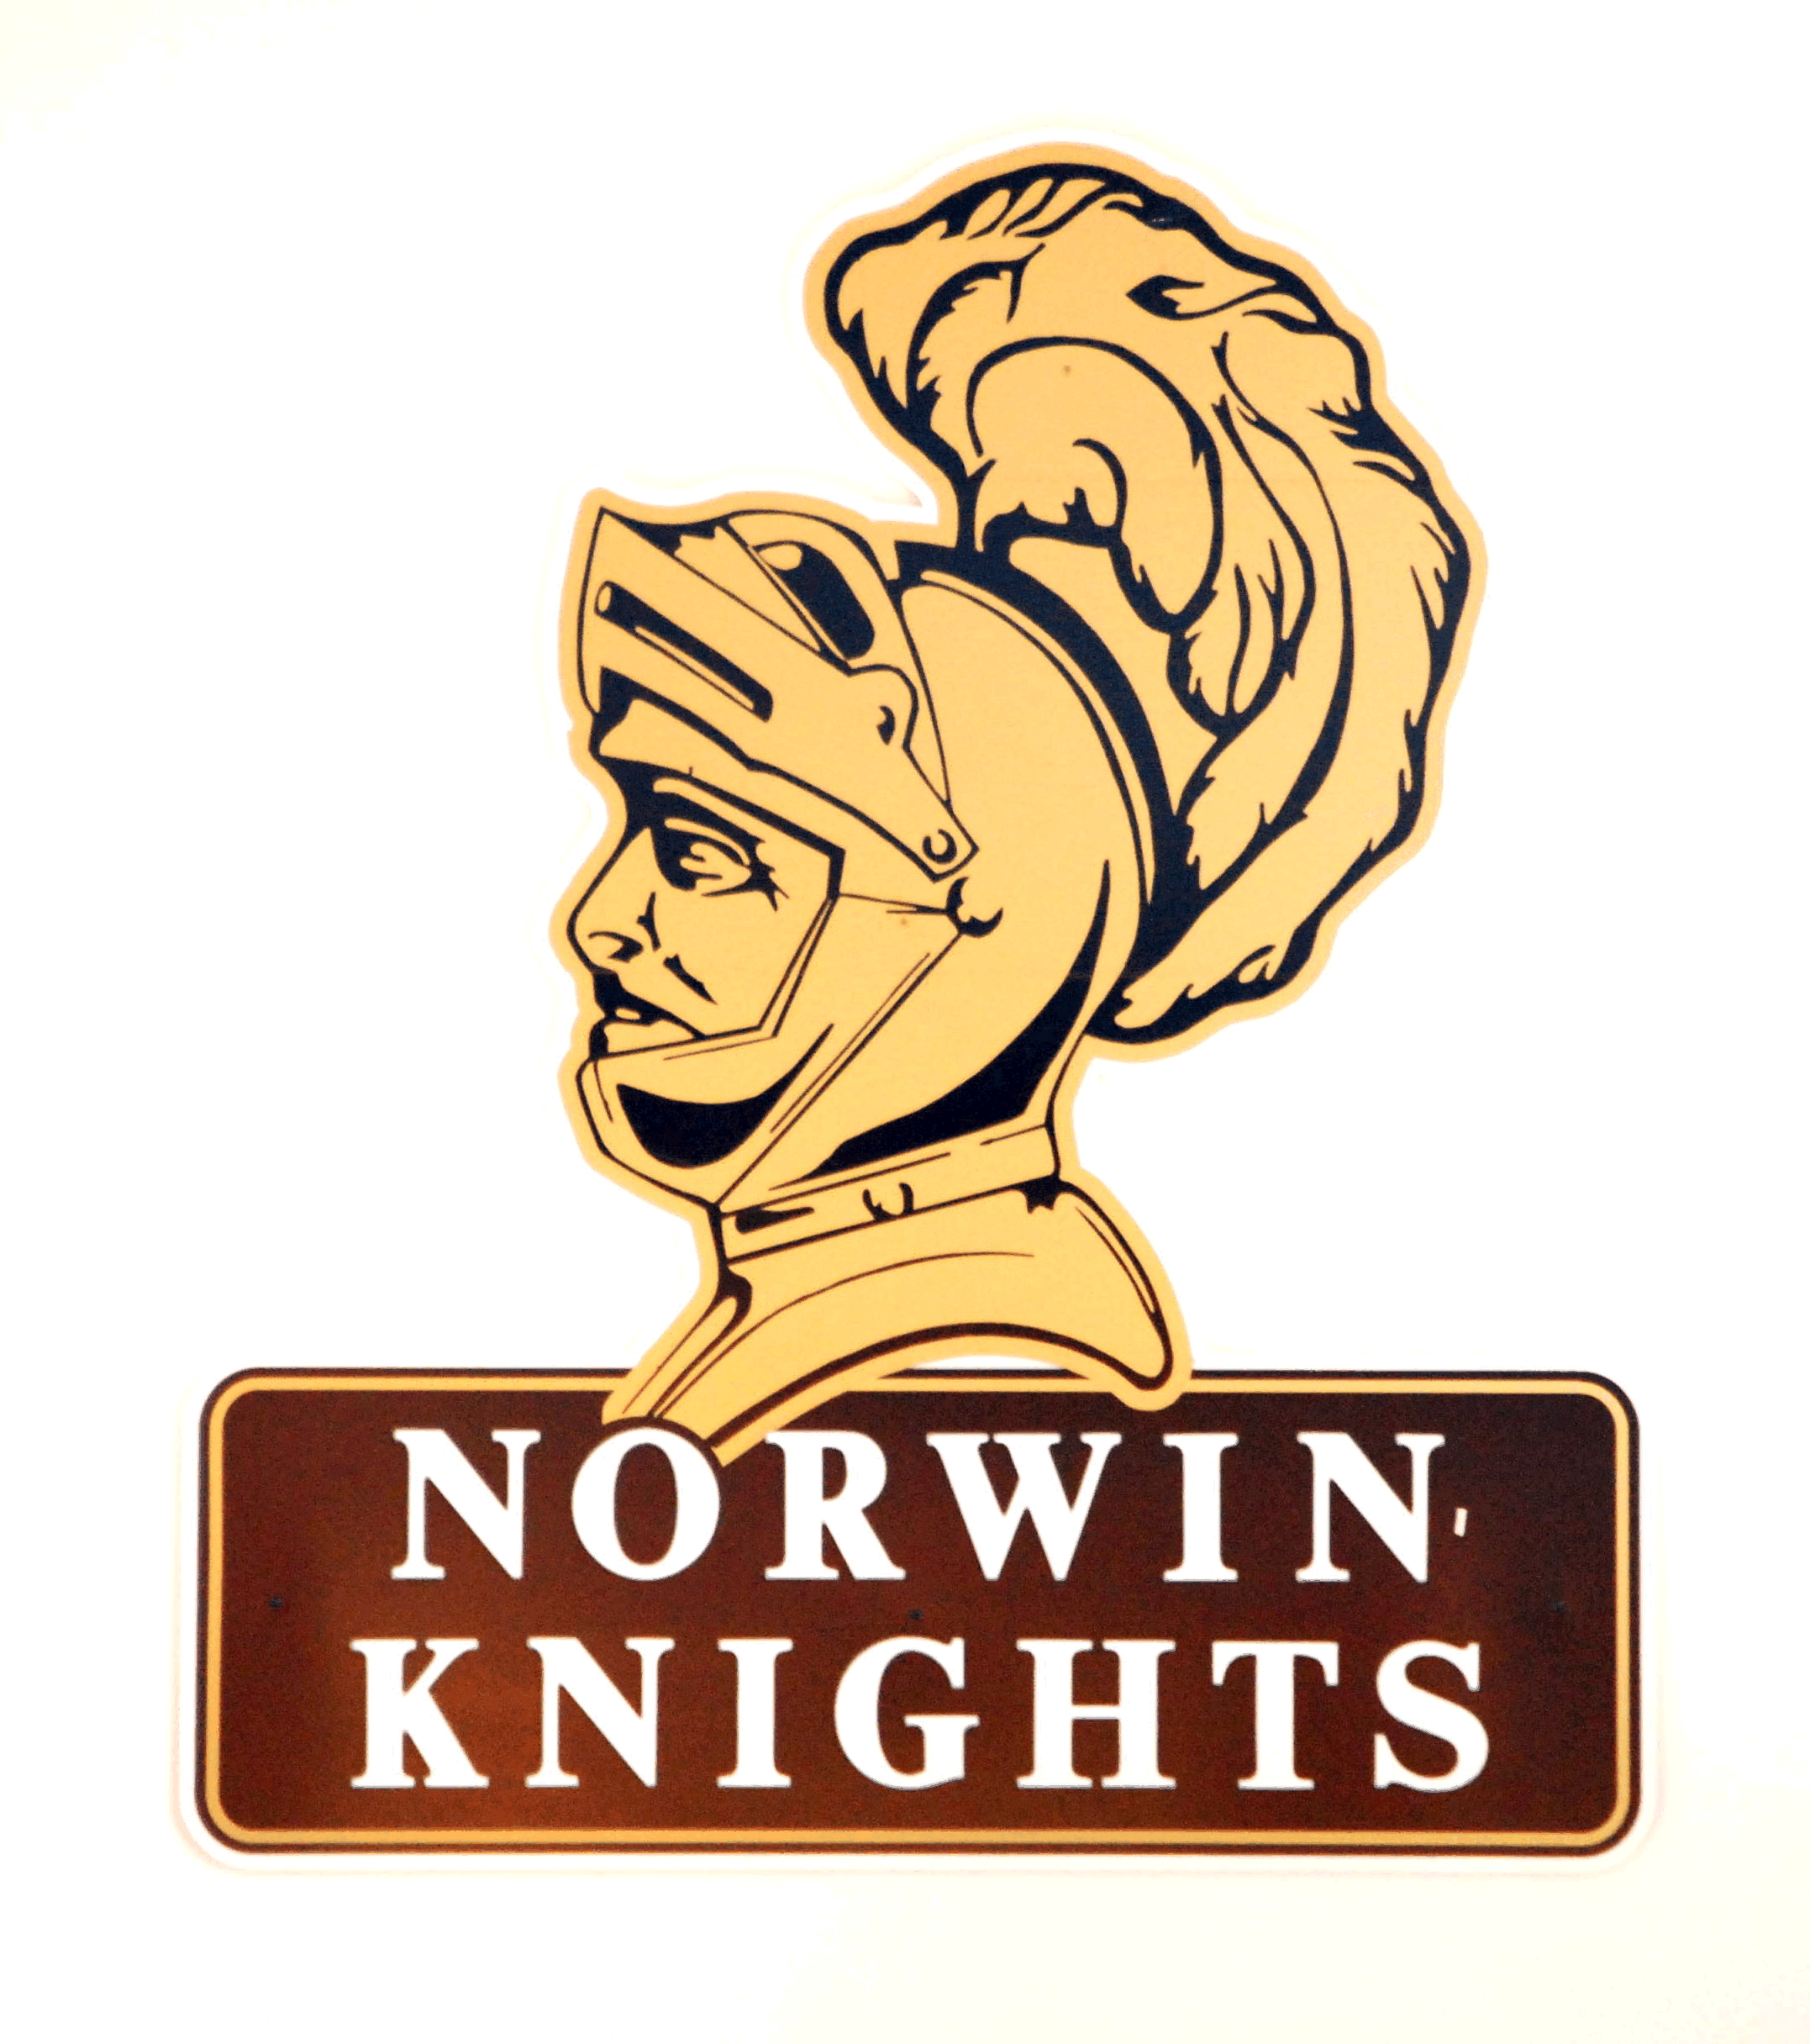
~Registration Form~

Name: _________________________Guest:________________________

Phone number:_____________________Email:_____________________

Friday Golf Outing

Irwin Country Club, Irwin
August 7, 2009 at 10:00 am
Number of people attending ____ @ $35.00 each = $____________

Friday Night Get-Together

The Rose Bar & Grille, White Oak
August 7, 2009 8:00 to Midnight
Complimentary Hors d'oeuvres, Open Bar, and Casual dress.

Number of people attending ____ @ $19.69 each = $____________

Saturday Evening Pig Roast & Party
VFW # 781 North Huntingdon
August 8, 2009 - Happy Hour at 6:00 pm - Dinner at 7:00 pm
Number of people attending ____ @ $35.00 each $____________

TOTAL AMOUNT Due: Before July 27th $____________

Optional: You may pay online at http://www.norwinclassof1969.com/

Comments: ___________________________________________________________

Mail this form and your check to:

Norwin Class of 1969

46 Buttermilk Hollow Road
North Huntingdon, PA 15642
Questions? Email Dave@NorwinClassOf1969.com
Or call 724-863-3890

