Print and mail this form
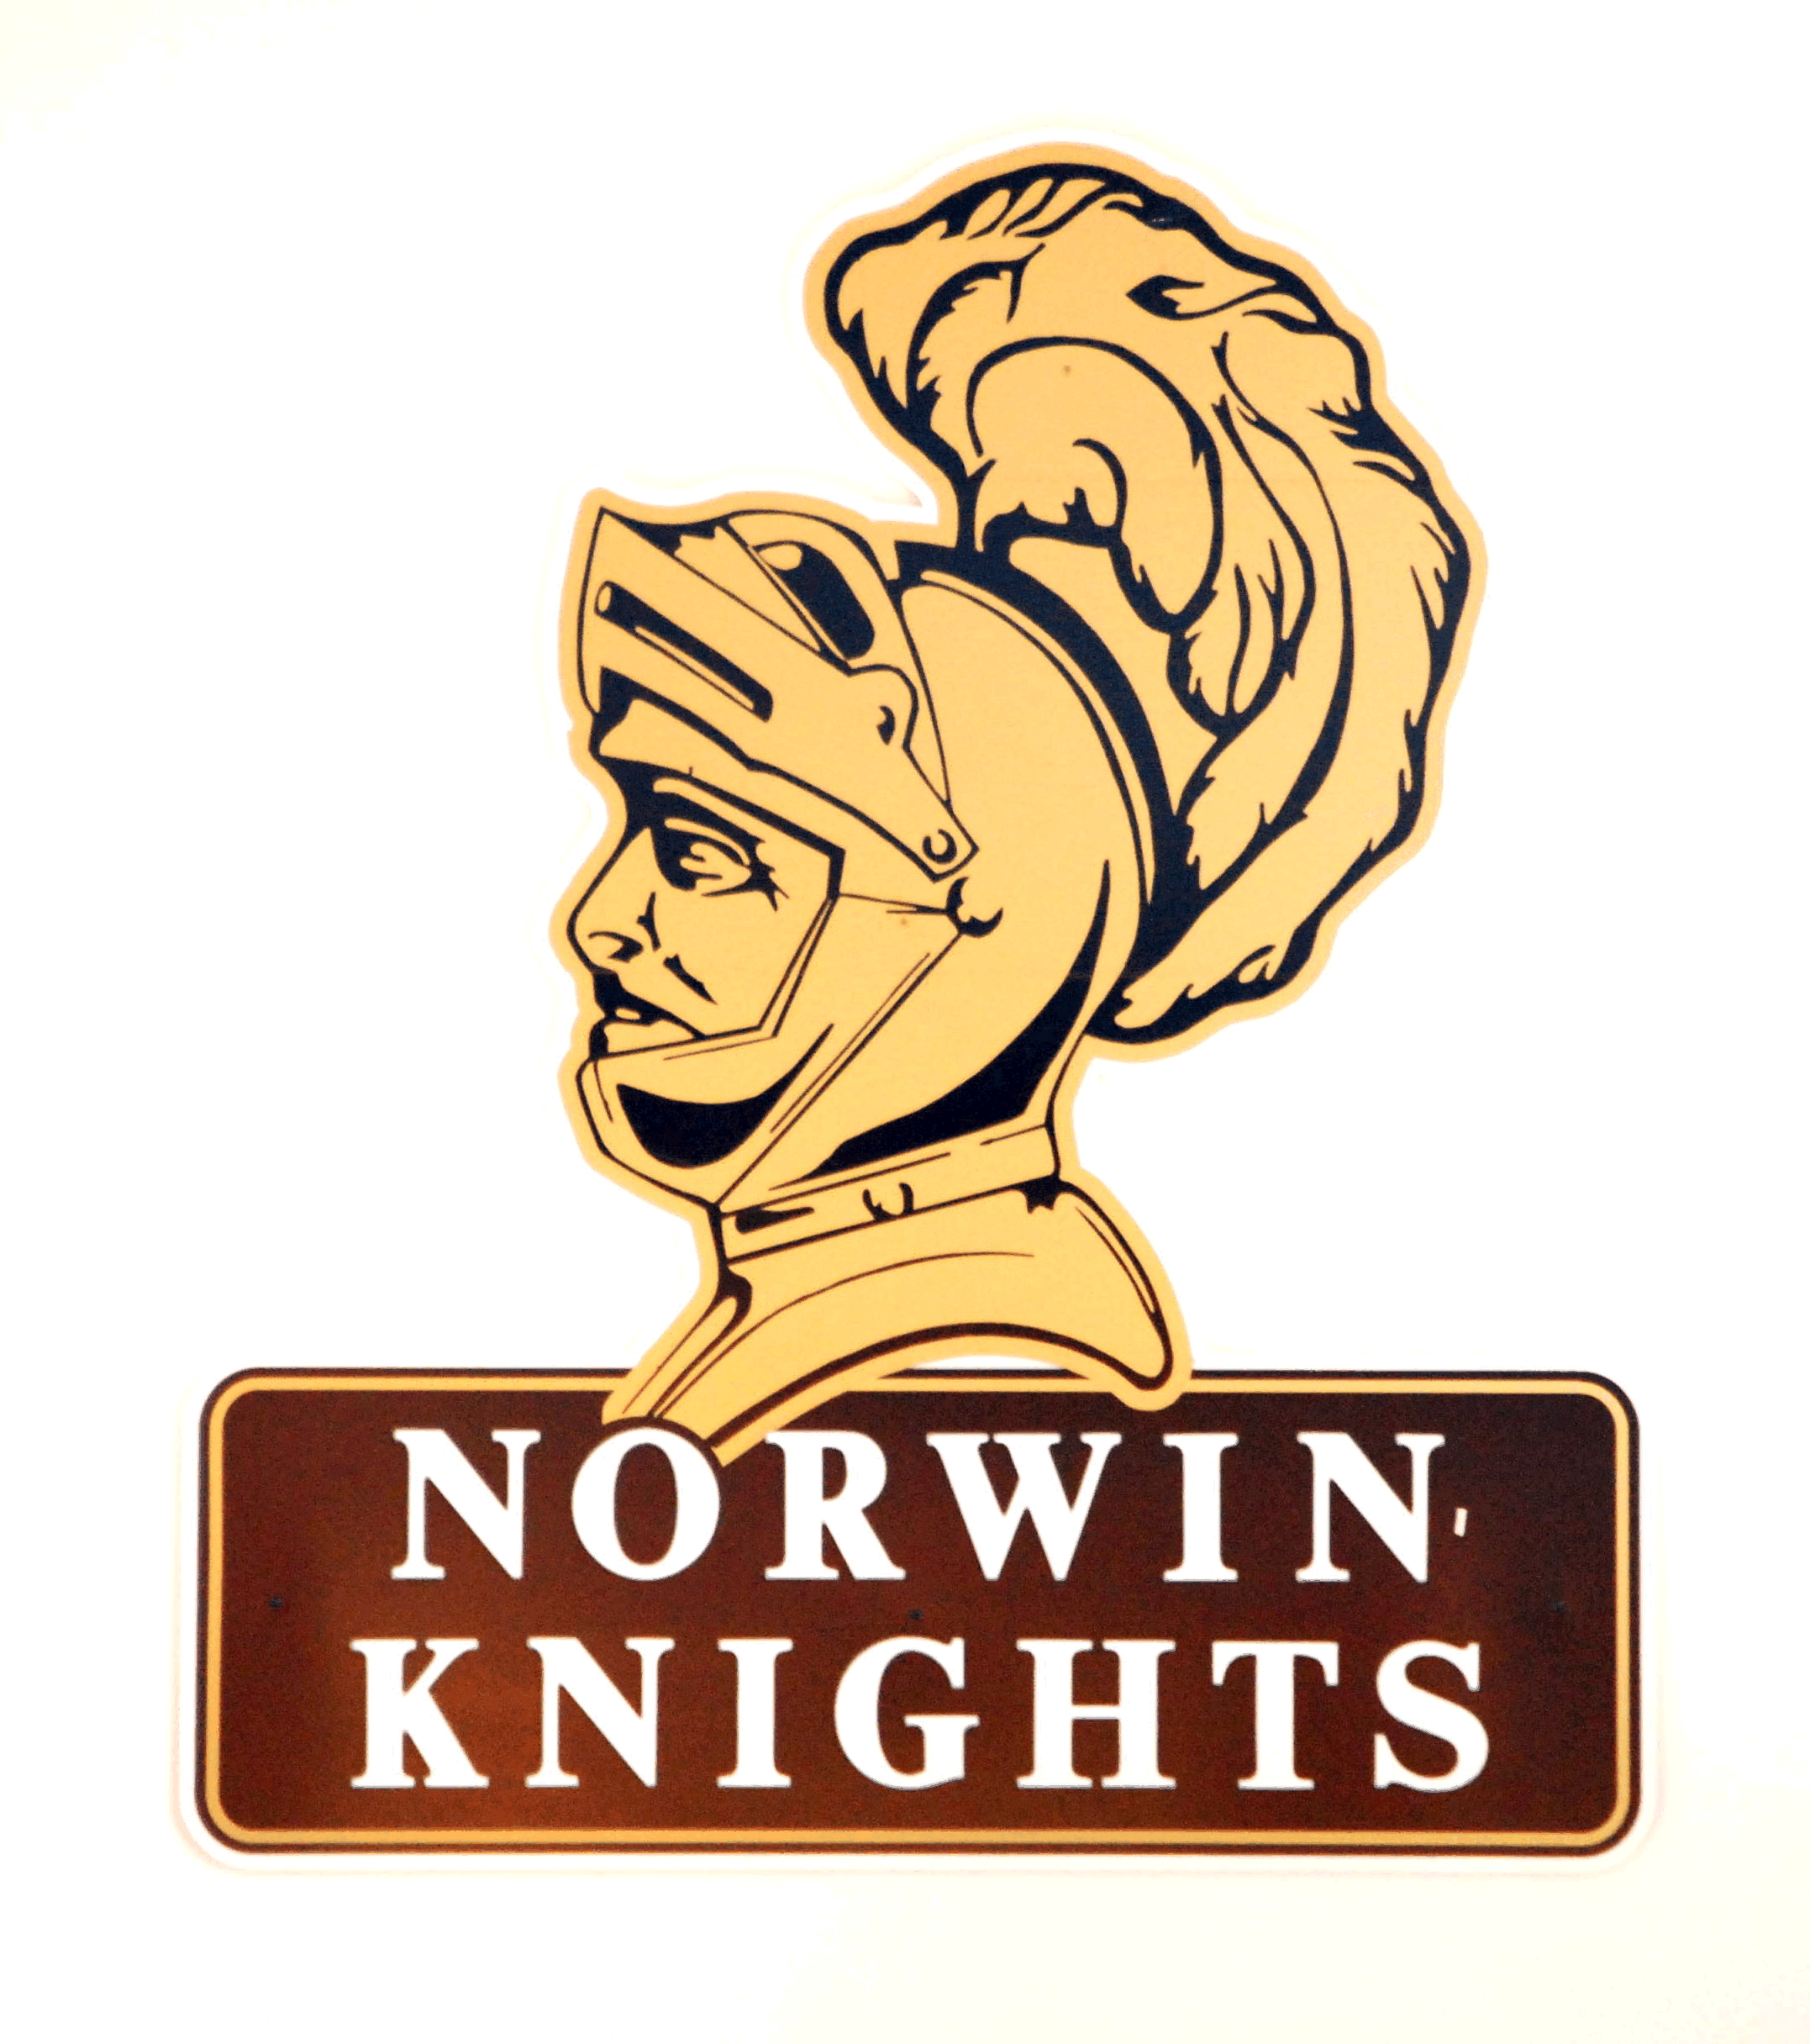

Norwin Class of 1969

~Mail Registration Form~

65th Birthday Celebration
Saturday August 6, 2016 at 6:00 pm
V.F.W. #781, 100 Billott Avenue

Dinner Buffet / Cash Bar / Entertainment / Dancing

This is an open invitation to all Norwin ‘69 graduates, friends, family members, other class graduates, and anyone who wants to have a good time!

Your name________________________________________________
Guest (s)_________________________________________________
Address__________________________________________________
__________________________________Email__________________

Number of people attending ____ @ $25.00 each = $____________

Optional donation $______________

TOTAL AMOUNT Due: Before July 27th $____________

Mail this form and your check to:

Norwin Class of 1969

46 Buttermilk Hollow Road
North Huntingdon, PA 15642
Questions? Email Dave@NorwinClassOf1969.com
Or call 724-863-3890

Comments: ___________________________________________________________
Optional: You may pay online at http://www.norwinclassof1969.com

